|  |
| --- |
| INFS 4950 |
| User Guide |
| HealthPal |

|  |
| --- |
| Michael Armstrong  11-29-2016 |

**Table of Contents**

**WARNINGS! [Please Read First]** 2

**Home** 3

**Doc Portal**

Doc Portal 4

Register 5

Manage Patients 6

Patient Records 7

Profile 8

**Assessment**

Register 9

Confirmation 10

Assessment 11

Results 12

**WARNINGS! [PLEASE READ FIRST]**

* When attempting to login, please do not press, “ENTER” on your keyboard. You must click the “Login” button using your mouse to login. If you press, “ENTER” on your keyboard you will be directed to the “Registration” page.
* When attempting to delete a patient from the system you must first delete any active assessments that they have on file.
* When leaving a comment on the “Results” page, do not use any single or double quotes. I have not figured out how to avoid SQL injections from breaking my application. Here are examples of a do and a don’t:
  + - * Don’t: “I can’t believe I’m seeing these results”
      * Do: “I cannot believe I am seeing these results”

**Home**

* The home page house the links to begin the assessment and enter the Doc Portal.
* The Home link on the home page will always direct back to the home page, no matter where you are in the app.

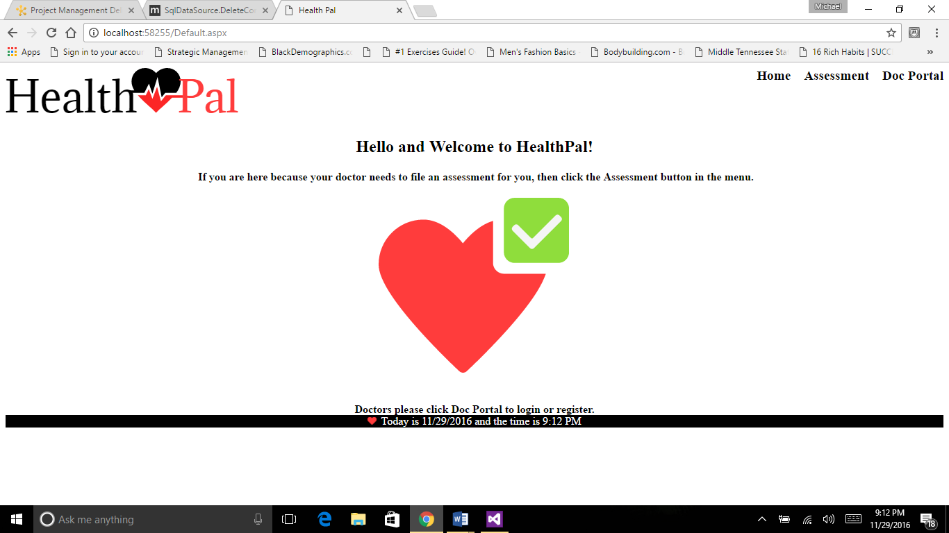

**Doc Portal**

**Doc Portal**

* In order to get access to the Doc Portal you must login.
* You must to be registered before you can login.
* The Doc Portal is for doctors only!
* Below is the screen that you will see after clicking on the Doc Portal link on the main page.

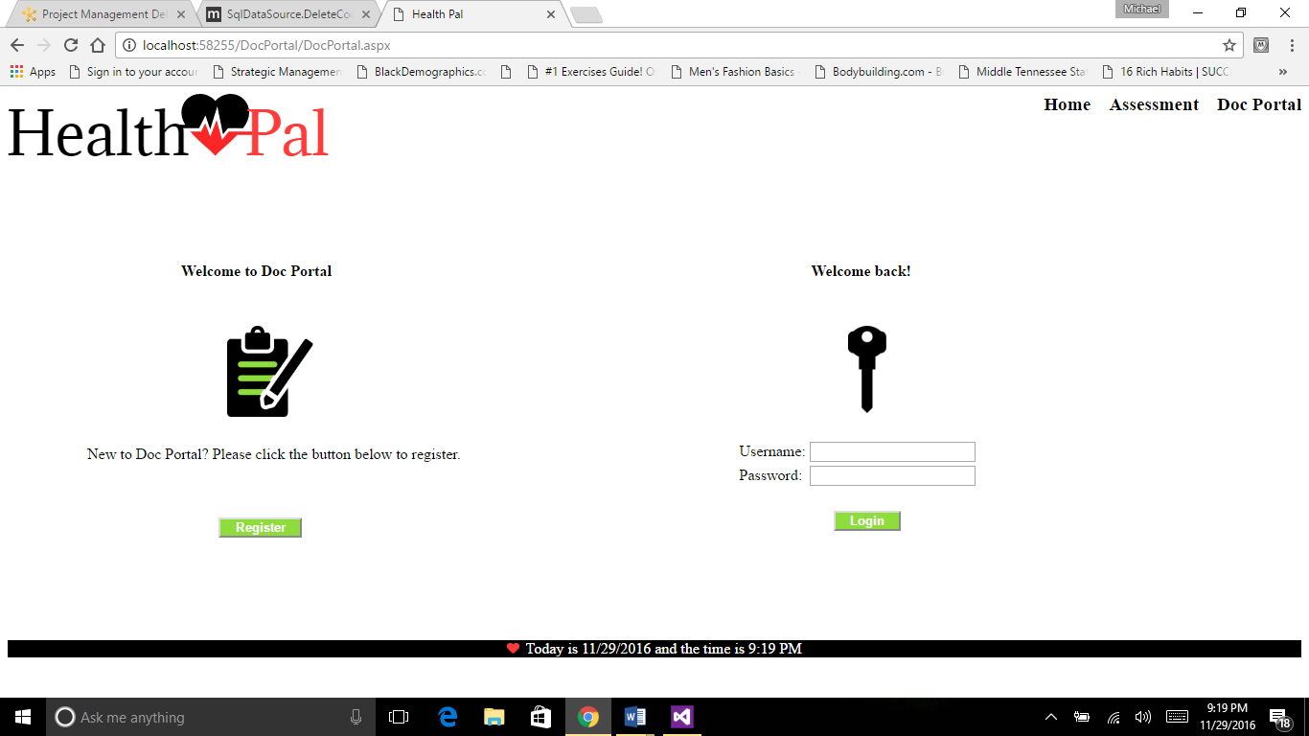

* Here you can either login using your user name and password or click register to create a profile with a username and password.
* Please do not press, “ENTER” on your keyboard when attempting to login. You must click the “Login” button with your mouse.

**Register**

* Below is the register page used to create a profile.

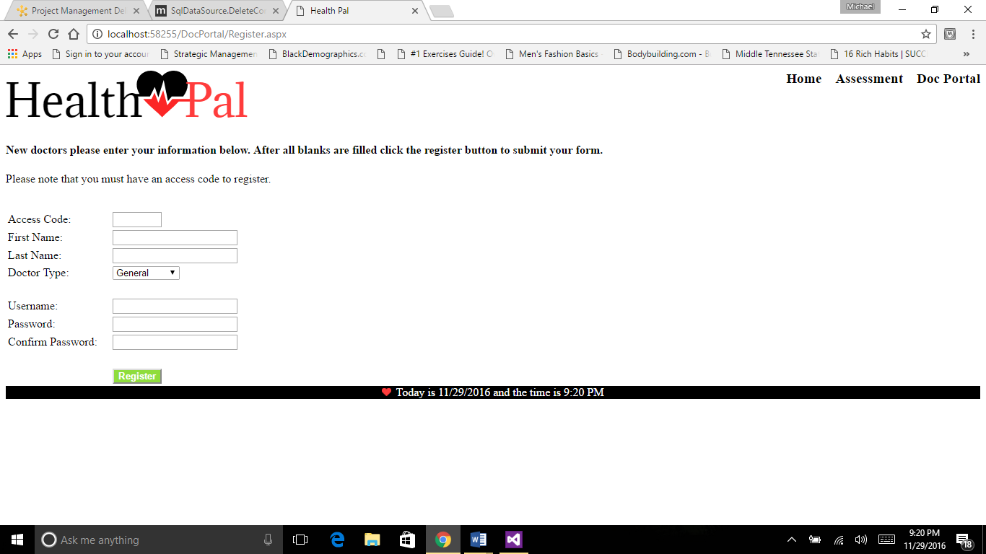

* You must have an access code to register. Access codes may be obtained from doctors that are already registered. Access codes are assigned to doctors after they are registered in the system. They can be found on the doctor’s profile page.
* After obtaining an access code from a registered doctor, you can finish the registration process by filling in all the blanks and clicking the “Register” button.
* After registering and logging in you will see the page below to confirm your login.

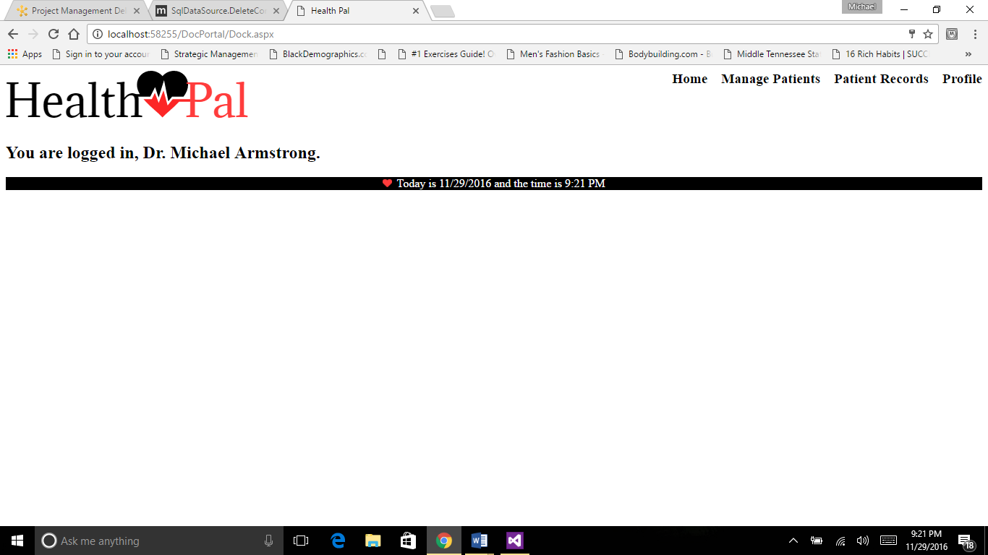

**Manage Patients**

* After a successful login, a different set of links will appear in the menu.
* The Manage Patients link will allow you to see all patients that you are currently serving only. You will not see other doctor patients.
* Here you can make updates by clicking the update button and delete patients by clicking the delete button.
* Note: Before deleting a patient, you must delete any active assessment that they may have.

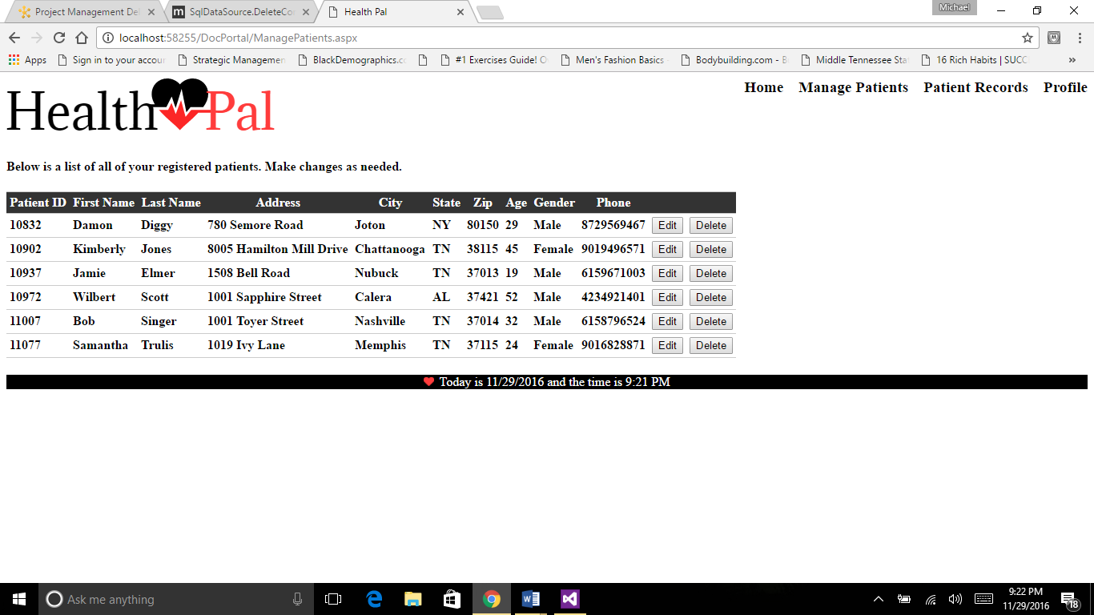

**Patient Records**

* When clicking on the Patient Records link you will be able to view all assessments that you patients have on file.
* Here you will also be able to delete them also.
* Note: Deleting an assessment is required before deleting a patient out of the system.

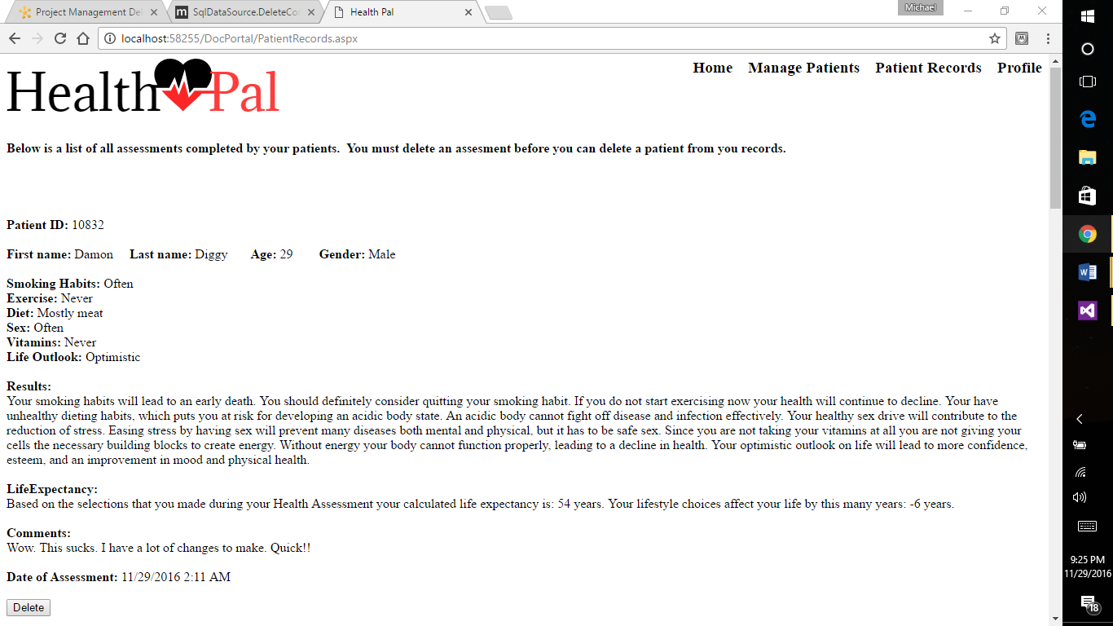

**Profile**

* The doctor profile is where all of the information that is stored about the doctor is found.
* The doctor’s access code will be located at the bottom of the page.
* The doctor’s type is the type of medical professional that they have identified themselves to be.

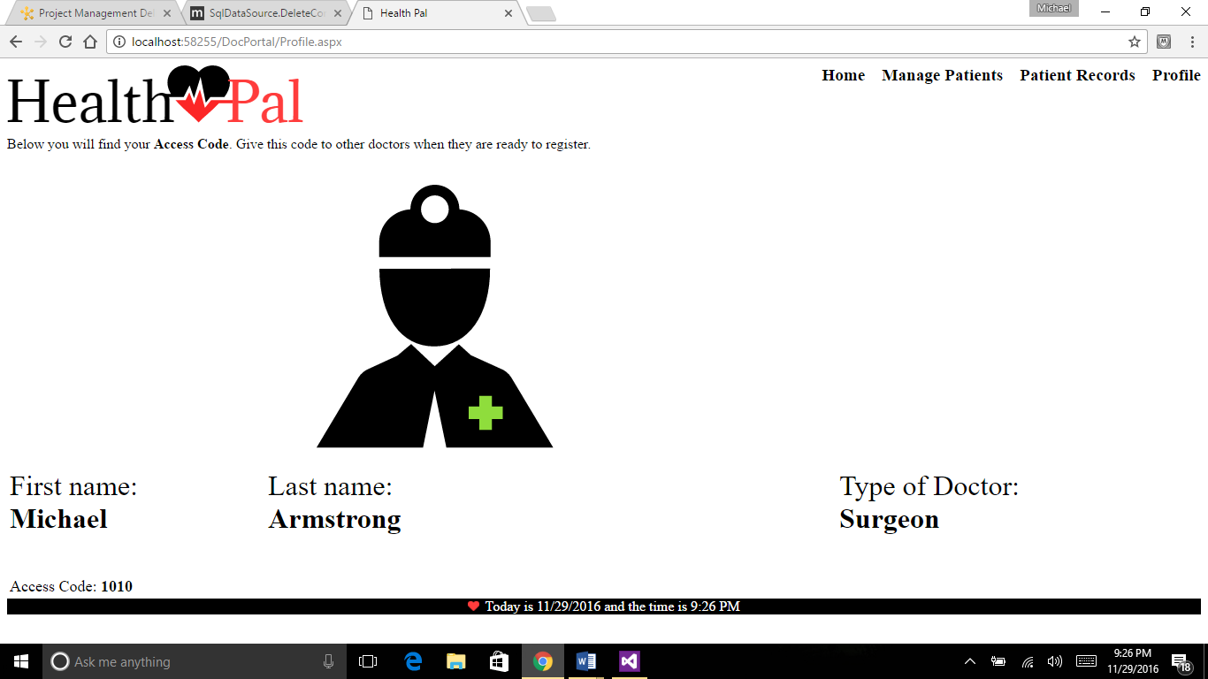

**Assessment**

**Register**

* To begin an assessment a patient must simply click the “Assessment” link in the on the home page.
* The first step of the assessment is to register.
* Once the register screen is loaded, the patient will fill out all the textbox’s then click the “Register” button.
* Here is an example of the registration screen:

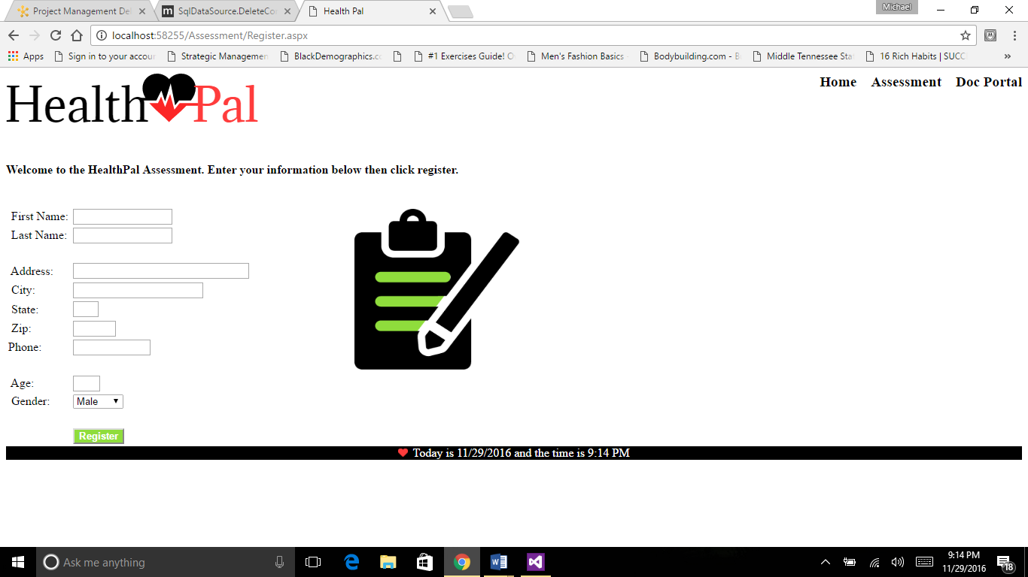

**Confirmation**

* After submitting the registration form, the patient will be instructed to confirm the information they have entered before moving forward.
* If the patient needs to make changes to the information before them, they can push the “Back” button to go back to the Register screen. If not, they will click “Continue” to begin the assessment.
* Here is an example:

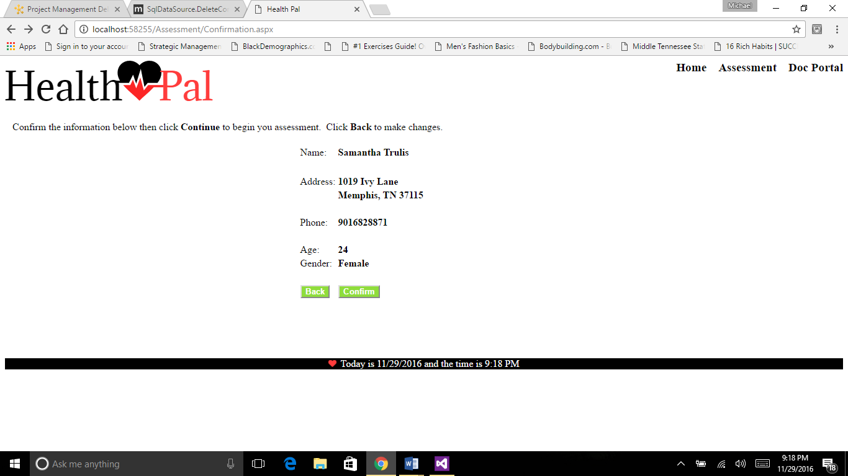

**Assessment**

* The assessment page will ask a few questions to put together results to display back to the patient.
* The first thing the patient should do is select their doctor from the drop down list at the top of the page.
* Next, the patient will mark radio buttons that reflect their status of smoking habits, exercise, diet, sex, multi-vitamins, and outlook of life.
* After the patient makes their selections, they will click the “Submit” button to generate a results report.
* Here is an example of the assessment:

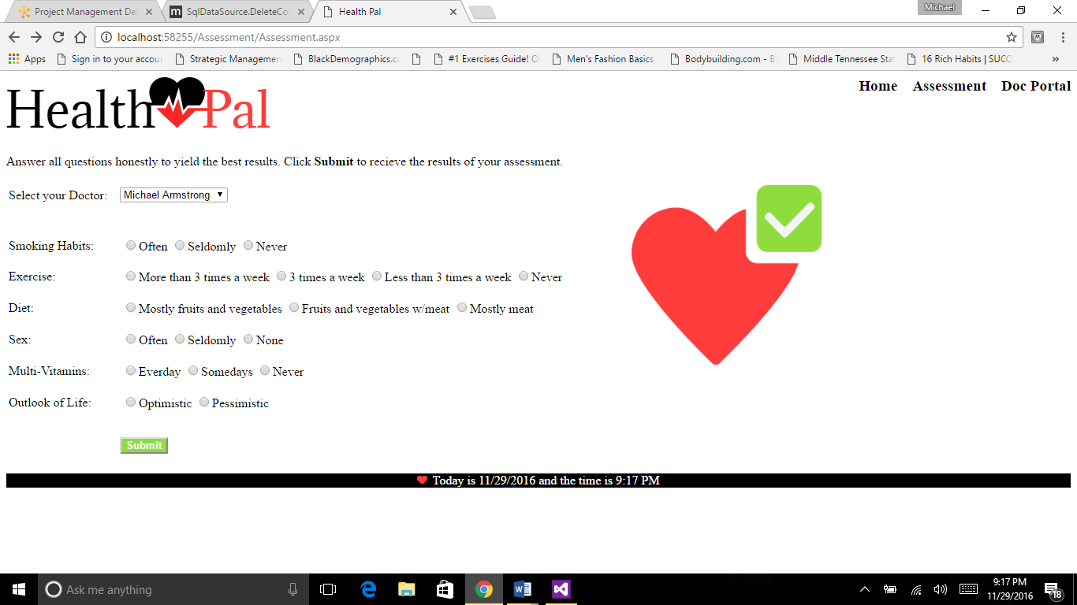

**Results**

* The Results page is the final landing page for the patient assessment experience.
* The Results page will take all of the information from the assessment and generate a results report that will give suggestions and advice about the patients’ lifestyle choices.
* The results report will also include a life expectancy age, which aims to predict how long the patient will live giving their current lifestyle. The life expectancy results also tell how many years their lifestyle choices are either adding or subtracting from their life.
* After observing their results the patient can leave comments.
* Note: Do not use single quotes or double quotes in the comment area. Instead of, “don’t” you should say, “do not”. Instead of, “I’m” you should say, “I am”.
* After adding comments please click the “Done” button to submit your results to your doctor and return to the home page.
* Here is an example:

